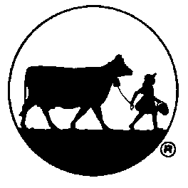
NEWS FROM THE LITTLE CREAMERY

Brownie + Cookie + Ice Cream = New flavor from Blue Bell, Brookie À La Mode Ice Cream

BRENHAM, Texas, March 26, 2026 — What’s a brookie? It is a delicious combination of two of the most popular baked desserts, a brownie and a chocolate chip cookie. And what could possibly top that? Blue Bell, of course! New Brookie À La Mode Ice Cream arrives in stores beginning today.

Brookie À La Mode is a rich, creamy brown sugar ice cream loaded with chunks of brownies and soft chocolate chip cookie pieces.

“We enjoy finding new ways to top already delicious desserts,” said Sara Schramm, Blue Bell marketing brand manager. “Blue Bell Ice Cream is the perfect addition to a brookie. Our new flavor starts with a delicious brown sugar ice cream, loaded with chunks of chewy brownies and soft chocolate chip cookies in every bite. It is the best of both, or all three worlds!”

Brookie À La Mode is available in the half gallon and pint sizes, but only for a limited time.

Also new and now available from Blue Bell is Honey Vanilla Ice Cream, a simple and delicious honey vanilla flavored ice cream. You can find it in the pint size while supplies last.

For those looking to reach their protein goals, Blue Bell released a new high-protein dairy dessert in March. The PRO pints, with up to 12 grams of protein per serving, are available in Chocolate, Coffee, Salted Caramel, Strawberry and Vanilla.

For more information about Blue Bell Ice Cream and a complete list of products available in stores, visit www.bluebell.com. Follow Blue Bell on Facebook, Instagram, and X for the latest updates.

##

ABOUT BLUE BELL CREAMERIES
Founded in 1907 in the small town of Brenham, Texas, Blue Bell Creameries is a top-selling ice cream manufacturer in the United States despite being sold in only 24 states. No matter how much the market grows, Blue Bell maintains its top-quality standards. With production facilities located in Brenham, Broken Arrow, Okla., and Sylacauga, Ala., the company offers more than 40 ice cream flavors as well as frozen snack items and health claim products.

##

